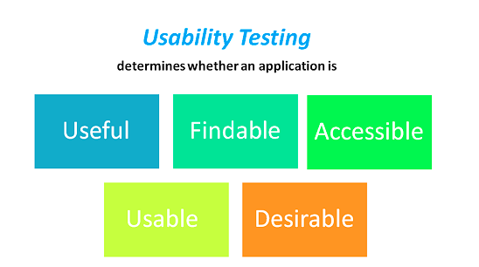
- What is usability testing in web testing?
Ans . USABILITY TESTING measures how easy to use and user-friendly a software system is. Here, a small set of target end-users, "use" the software system to expose usability defects. This testing mainly focuses on the user's ease to use the application, flexibility in handling controls and the ability of the system to meet its objectives. It is also called User Experience(UX) Testing.

- Explain the difference between HTTP and HTTPS?
HTTP | HTTPS
HTTP URL in your browser’s address bar is http:// | HTTPS URL in your browser’s address bar is https://
HTTP is unsecured. | HTTPS is secured.
HTTP sends data over port 80 | HTTPS sends data over port 443
HTTP operates at application layer | HTTPS operates at Transport layer,
No SSL certificates are required for HTTP | SSL certificates are required for HTTPS
HTTP doesn’t require domain validation | HTTPS requires at least domain validation and certain certificates even require legal document validation.
No encryption in HTTP | with HTTPS the data is encrypted before sending.

- Write the test scenarios for testing a web site?
Ans.
- Mandatory field must perform validation and indicated by asterisk(*) symbol whenever filling any form.
- Correct error should be displayed whenever a false attempt happened.
- Alignment of the data and block on the website should be proper.
- Refreshing the page should refresh the web page and display the updated data on the web page.
- Input fields should be checked for the max field value. Input values greater than the specified max limit should not be accepted or stored in the database.
- Check cookies used in an application.
- Check the functionality of buttons available on all pages.
- The scrollbar should be enabled only when necessary.
- Font size, style, and color for headline, description text, labels, and grid info should be standard as specified in SRS.
- The description text box in the form or comment section should be multi-lined.
- The user should not be able to type in drop-down select lists.
- Radio Buttons should be selectable and default radio buttons should be selected when page loaded.
- Check all pages for broken images.
- Check all pages for broken links.
- Icon of website should be correct.
- URL of the website should be reachable.
- Website should be responsive.
- Credentials should be secured.

- Write a few Test Cases on GMail functionality.
https://docs.google.com/spreadsheets/d/1vu0-bp7dAlheVha1yTygh4QDSj3iBeDlE_mlqeJYyGQ/edit?usp=sharing

- Write any 5 common ATM Machine functionality.
Ans.
- We can view the current balance of our account.
- We can withdraw the amount from our account.
- We can change the PIN of our card.
- We can transfer funds from our account.
- We can view our account statement in the hard copy form.

- Give some examples of web applications that are used in our day to day life.
Ans. FaceBook, Google+, LinkedIn, Pinterest, Twitter etc.

- What are the advantages of Using Cookies?
Ans.
- It is used by the websites to track the visitors to keep the user information such as the username , interests , Password Remember Option , etc
- The cookies created in one browser ( e.g in Google Chrome ) will not be accessed by another browser ( Internet Explorer/Firefox ) .
- The cookies are simple to use & implement.
- Cookies are used to maintain the session between the client and the server.
- Cookies are persistent , When the cookie is set on the client’s browser , it can persist for days , months or years
- The cookies are stored on the client’s hard disk , so , if the server crashes , the cookies are still available .
- The cookies make browsing the Internet faster & easier
- The cookies do not only remember which websites you have been to , They remember the information about forms , They can fill out the address forms quick & efficient.

- What is XSS and how can we prevent it?
Ans. Cross-site Scripting (XSS) is a client-side code injection attack. The attacker aims to execute malicious scripts in a web browser of the victim by including malicious code in a legitimate web page or web application. The actual attack occurs when the victim visits the web page or web application that executes the malicious code. The web page or web application becomes a vehicle to deliver the malicious script to the user’s browser.
Prevention from XSS are :

Escaping from XSS: Escaping is the primary means to avoid cross-site scripting attacks. When escaping, you are effectively telling the web browser that the data you are sending should be treated as data and should not be interpreted in any other way. If an attacker manages to put a malicious script on your page, the victim will not be affected because the browser will not execute the script if it is properly escaped.
To keep yourself safe from XSS, you must sanitize your input. Your application code should never output data received as input directly to the browser without checking it for malicious code.

- Write a few Cross Browsing Testing TCs for any website.
https://docs.google.com/spreadsheets/d/1vu0-bp7dAlheVha1yTygh4QDSj3iBeDlE_mlqeJYyGQ/edit?usp=sharing

